Ahmet Bahar

Mustafa Salih Oğuz

Sinan Barış Cömert

Serkan Ekrem Cengiz

Portable File Manipulator (Pofm)

INTRODUCTION

Firstly, we will explain that how Portable File Manipulator program is running and how user will use this program. Portable File Manipulator runs different functions .For example, creating a file, deleting, rename a file and copy a file. On the other hand, this program does some different performances on the text. The user can change what user wants such as append text end of the file, insert the text, remove the text and show the text. Therefore, when any user use that program, user can change on the while using at the same time. Portable File Manipulator has other feature that this program can run all operating systems such as Windows, Linux and IOS. Pofm does not give an error in all systems.

This program start to run with main screen. This screen show the command with short code:

E: Exit

C: Create

D: Delete

R: Rename

O: Copy

M: Move

A: Append text

T: Delete text

S: Show text

When user runs the program, the user will see above screen. After that, user will choose the letter and automatically the command. Therefore, one of commands is run.

MENU SCREEN

This menu shows the user how will continue to using that program. The main menu window includes all commends. If user write wrong short code, the program will ask a command again. If it is correct, it will ask new question about that question. However, while running program memory management works perfectly. We used all memory choices. If user see the error, user can use ‘E’ letter and the program closed.

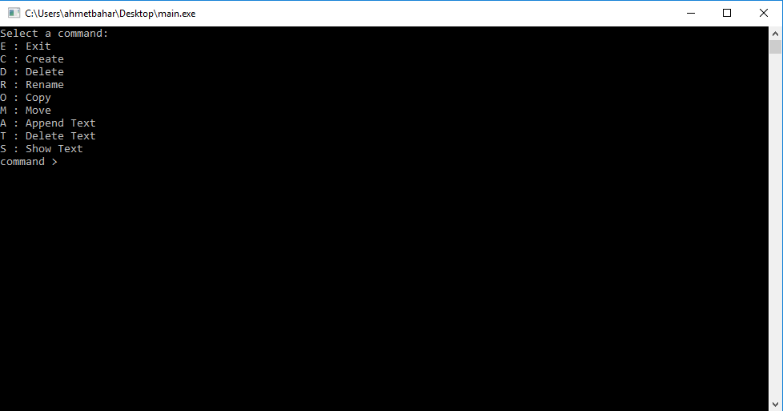

When the Pofm is run, the main menu screen is seen like above.

CREATE A FILE

The user create a file while using the command of creating a file. The type of file can be pdf, mp3, txt etc. However, the user should be write the directory while creating a file. On the other hand, if user want to create a file who will be same name with a file on the computer, the program will not create a file with that name and it will say that this file already exist. However, there is not a file that name, portable file manipulator will create a file and ask another command.

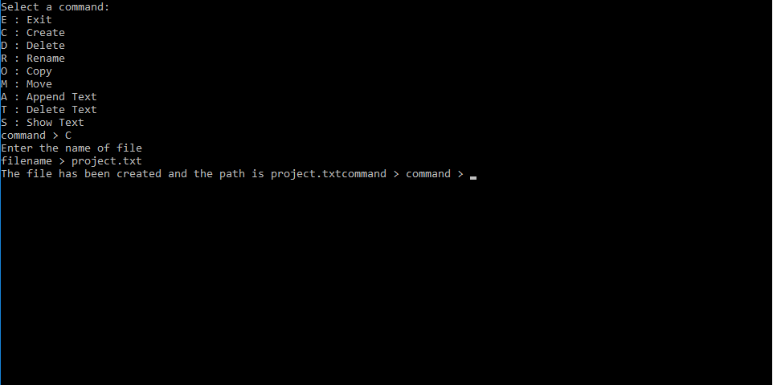

The function of create a file is running like above.

DELETE A FILE

The user can delete the file with Portable File Manipulator. This program does not look at the type of the file while deleting. If there is a file, program deletes that file; on the other hand, if there is not a file, program gives an error.

RENAME A FILE

Portable File Manipulator allows renaming a file. While changing a filename, the type of file is not important for the program. Because, this function only does not change the name. It changes name and its directory at the same time.

This function starts to ask the command. After user choose the R, the program asks the name of old file. After the user wrote the old file the program asks the name of new file .If old file is exist, the function will work successfully. However, if there is not exist, the function will not work.

COPY A FILE

We explain the functions that the program includes. Copy a file is the one of them.

* printf("Enter the file name to be copied: ");
* scanf("%s", source);
* printf("Enter the destination that file will be pasted: ");
* scanf("%s", target);

While above codes, pofm will copy the file. First, it asks the name of the file and it takes the source the name. After that, it asks the destination that file will be pasted and it takes the target.

When we check the directory of the file for the function of copy a file. The extension of the file will be the same as the extension of the copy.

MOVE A FILE

The user can move a file original place to somewhere that the user wants. The function of move a file has a basic logic. If somethings move place to other place. It should be deleted from original place and copied new place. We created the function as a connection of the function of delete a file and copy a file.

This function works that first it asks the name of the file that will be moved and after that, it asks the destination of the file that will be moved. This function actually delete the file the first place and copy the new place.

APPEND THE TEXT

This function provide to append text at the end of the file. The user can append something a file. Nevertheless, the file should be exist before the user does not append.

First, program asks the file of name that append text. Second, program will ask that what will write at the end of the file. The user will add what he wants. After that, post will be added in the file. If there is an error while running function, the function will return and caution. On the other hand it will continue.

DELETE THE TEXT

This function provides to remove the content of the file. Therefore, there should be a file for removing. This function also works like a append text. The program asks the file of removing, and after entering the name, the function will delete the content of the file.

SHOW THE TEXT

The user can see the total text of the file with the function of show the text. This function is similar with the functions of append text and other editing types. If user wants to see specific line in the text, user can search in the text and after user can pass other lines for reading.

This function asks the user the which file do you want to see, and after user enters the name of the file, user can see the whole text.

HELP

Help utility created for the users. If user cannot solve how can use the program, help utility can help the users. Help utility includes the explanation for all functions. We will explain more efficiently in the user manual.